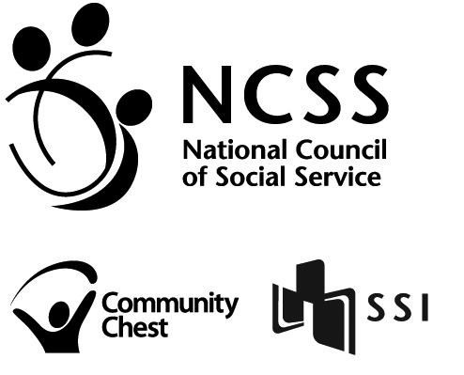

INTER-BANK GIRO – DIRECT CREDIT AUTHORISATION FORM

This form is to be completed by the supplier of the National Council of Social Service. Payment will be credited directly into the designated bank account stated below. The Supplier has to complete Part 1 of the form and obtain the Account Holder’s banker’s certification in Part 2. Alteration should be signed by the authorised signatory. The duly completed form must be returned by post to:

National Council of Social Service
VCF Secretariat
170 Ghim Moh Road #01-02
Singapore 279621

PART 1: FOR COMPLETION BY APPLICANT
1. | Name of Organisation:
2. | E-mail Address: ______________________________ Fax no: ___________________
3. | Bank & Branch Name
4. | Name of Account Holder
5. | Bank Code |  |  |  |  |  |  | Branch Code |  |  |  |  |  |  |  | A/C Number to be Credited
6. I/We consent to the bank’s disclosure of the relevant particulars of my/our account(s) requested for in this document.
 | Organisation’s Stamp & Authorised Signature/ Applicant’s Thumbprint/ Signature |  |  |  |  |  |  |  |  |  |  |  |  | Telephone No. |  |  |  |  |  |  |  |  |  |  |  | Date

PART 2: FOR COMPLETION BY FINANCIAL INSTITUTION
We confirm that the particulars in Part A above are correct. Item 3 of Part A is in accordance with the account number format for the Interbank GIRO participating bank.
 | Bank’s Stamp &  Authorised Signatures |  |  |  |  |  |  |  |  |  |  | Authorised Signatory’s  Name & Contact Number |  |  |  |  |  |  |  |  |  |  |  |  |  |  |  | Date

PART 3: FOR OFFICIAL USE BY NCSS ONLY
 | Effective Date: |  |  |  |  | Date of Acknowledgement: |  |  |  |  |  |  |  |  |  |  |  |  |  |  |  | Acknowledged by:

